Experiment: 7
Analog Beamforming Analysis Using MATLAB

Aim
To analyze the performance of analog beamforming by studying beamforming gain, beam width, and main lobe direction using MATLAB.
Objectives
1. To analyze the beamforming gain achieved by varying the number of antenna elements in an analog beamforming system using MATLAB.
2. To compare the beam width of an antenna array for different beamforming configurations using MATLAB.
3. To analyze the main lobe direction by steering the antenna array beam to different angles using MATLAB.
Objective – 1 Analyze Beamforming Gain (dB)
MATLAB Code:
clc;
clear;
close all;
antennas = [2 4 8 16 32]; % Number of Antenna Elements
gain = 10*log10(antennas); % Beamforming Gain (dB)
figure
bar(antennas, gain)
grid on
xlabel('Number of Antenna Elements')
ylabel('Beamforming Gain (dB)')
title('Beamforming Gain for Different Antenna Array Sizes')
OUTPUT
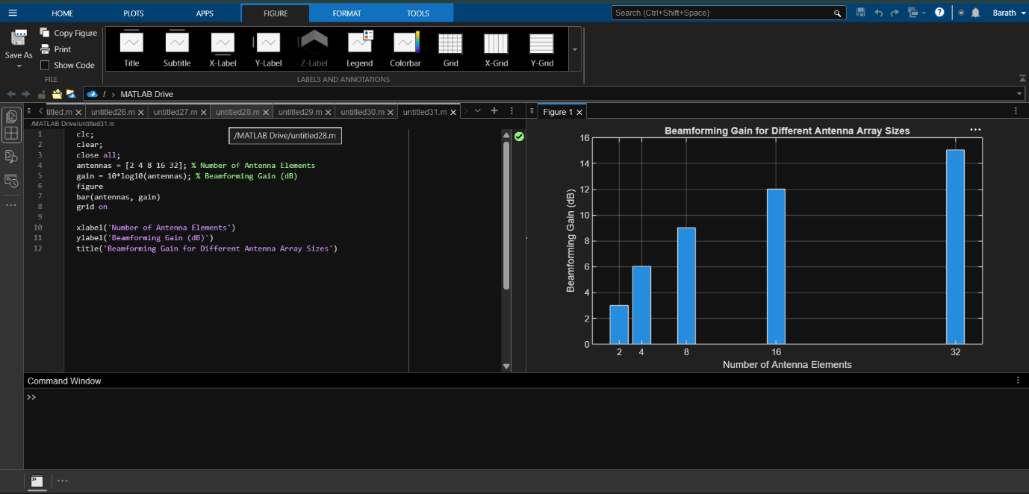Objective – 2 Compare Beam Width (Degrees)
MATLAB Code:
clc;
clear;
close all;
antennas = [2 4 8 16 32]; % Number of Antenna Elements
beamwidth = [90 45 22.5 11.25 5.625]; % Beam Width (degrees)
figure
plot(antennas, beamwidth,'o-','LineWidth',2)
grid on
xlabel('Number of Antenna Elements')
ylabel('Beam Width (Degrees)')
title('Beam Width for Different Antenna Array Sizes')
OUTPUT
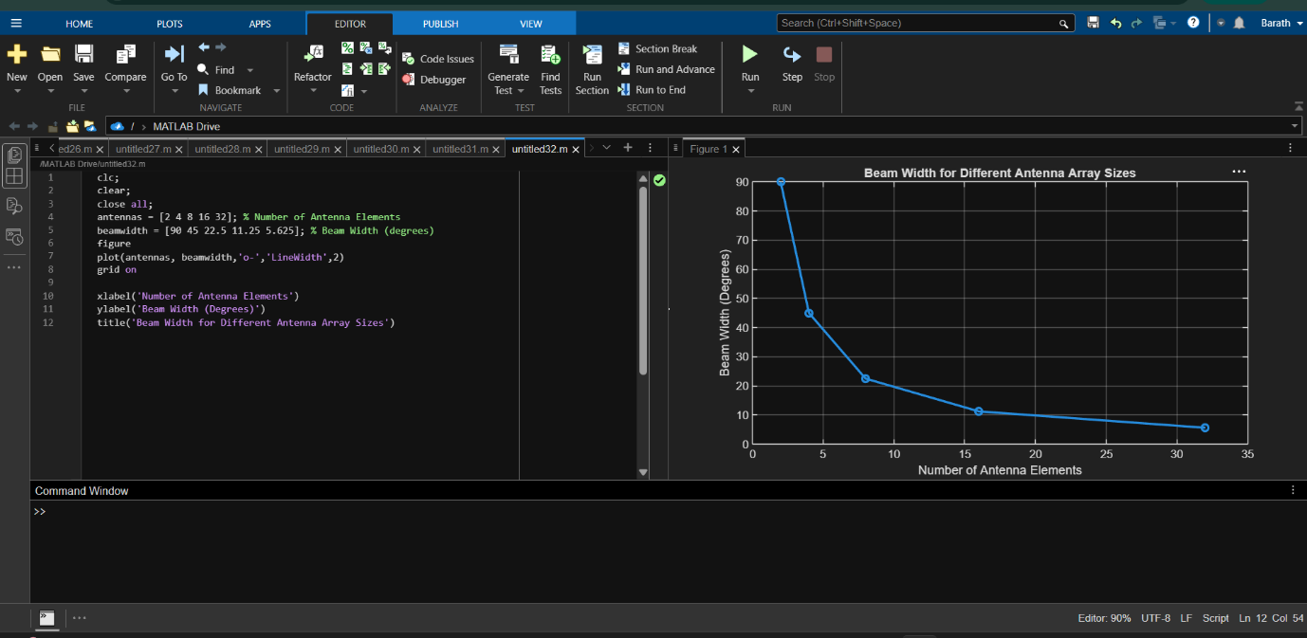
Objective – 3 Analyze Main Lobe Direction (Degrees)
MATLAB Code:
clc;
clear;
close all;
theta = [-60 -30 0 30 60]; % Main Lobe Direction (degrees)
gain = [1 1 1 1 1]; % Constant normalized gain
figure
polarplot(deg2rad(theta), gain, 'o', 'LineWidth', 2)
title('Main Lobe Direction in Analog Beamforming')
OUTPUT
